Table Boot
Compensate uneven floor

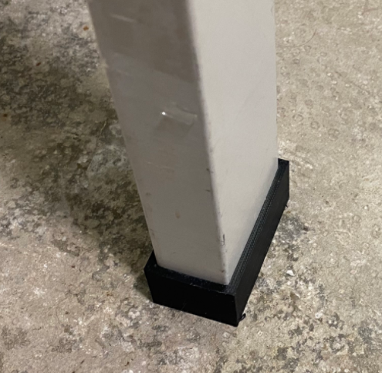

Project Goals
I have a very unequal floor in my cellar so placing a table is always challenging because it is dancing between the 4 legs.
So that’s why I created this compensation boot than can be applied to one leg to make the table stable.

TableBoots Sketch
Compensation height: 13 mm
Size: 50 x 25

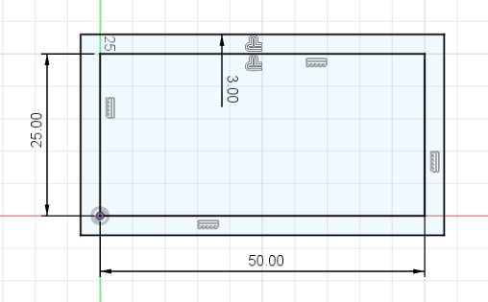

TableBoots 3D Model
I have extruded the shape 13 mm from the bottom and 10 mm in the top direction
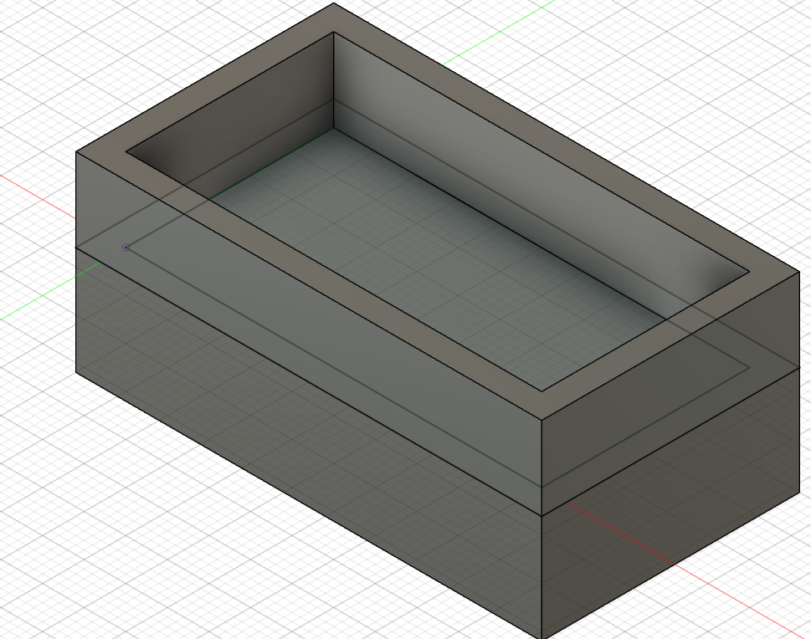

3D Printer layout

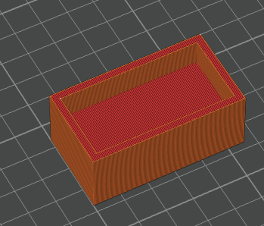

Final result

